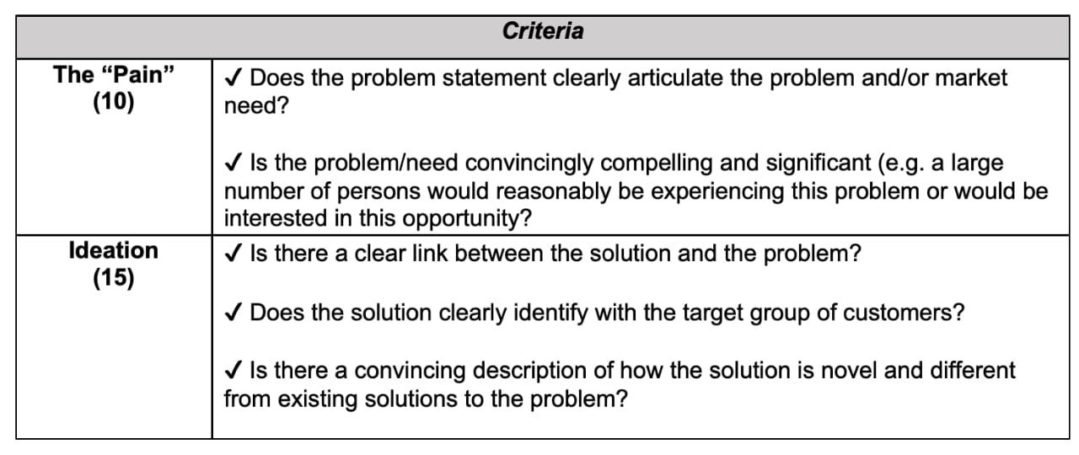

Hello good day. I’m Reanna and let me introduce you to, the Data Moguls, Gregory Woolery, Samuel Matheson, Murphy Facey and myself. We are a team of hardworking and innovation 3rd and 4th year Utech, SOBA and SCIT students who’s planning to participate in the Sagicor Innovation challenge.

At first glimpse of this competition, a mighty flame was lit throughout this team that served the purpose of directing Data Moguls towards an idea that would assist over 285 million visually impaired individuals around the world. Not only are the individuals in this bracket held back from enjoying sightseeing of the world view but also, they develop a strong sense of hearing that they rely on heavily which does not always prove reliable on local or general streets.

Since technology is one of the bridges that ties the world together as well as can be used to protect us, why not combined two fundamental attributes in such a way as to give a helping hand to the visually impaired.

In this light we have devised a strategy that uses speech, text and image processing to visualize the environment and relay it in speech or haptic feedback to the target audience. We call it WESUH, We See You Hear. It operates with a camera and microphone device facing outwards their bodies and earphones plugged in that relay helpful responses to the user such as

Haptic and audio to signal stopping when a car is passing

Navigating through their homes or on the street

Telling which friends are around them and storing that face for future references

Or even responses such as “Hey Reanna, there is a construction site ahead, please turn around”

We believe each person can enjoy their days regardless of any challenges and innovation such as this are needed in this strong technological era. Surely the provision of this application can one day safe the lives on individuals and provide the visually impaired with even more options of living.